Security Assessment and Red Team Operations Report

1. Executive Summary
This assessment simulated multiple offensive security and red team activities within a controlled virtual lab environment. The objective was to identify vulnerable services, validate exploitability, demonstrate post-exploitation activities, analyze malware detection capabilities, and evaluate password security weaknesses. The engagement included network scanning, exploitation of vulnerable services, credential attacks, malware analysis, post-exploitation enumeration, and security documentation. The assessment highlighted weaknesses related to vulnerable services, weak passwords, insufficient monitoring, and insecure credential handling practices.

2. Network Scanning
Nmap was used to perform service enumeration against the Metasploitable2 virtual machine. The scan identified multiple vulnerable public-facing services including FTP, IRC, and Samba.
Port | Service | Version
21 | FTP | vsftpd 2.3.4
6667 | IRC | UnrealIRCd
139/445 | SMB | Samba smbd 3.x

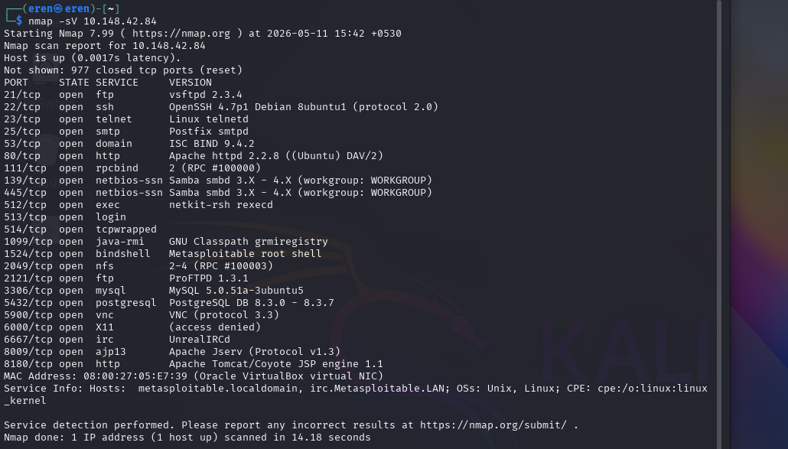
Figure 1: Network Service Enumeration and Version Detection via Nmap

Scan Analysis
A stealth scan (-sS) generated minimal connection logging and reduced visibility, while an aggressive scan (-A) provided detailed service, operating system, and script enumeration information. Aggressive scanning produced significantly more identifiable traffic and increased detection visibility compared to stealth scanning techniques.

3. Vulnerability Scanning
OpenVAS vulnerability scanning identified multiple high-risk vulnerabilities within the Metasploitable2 environment.
Vulnerability | CVSS Score | Description
VSFTPD Backdoor | 7.5 | Allows unauthorized remote access
UnrealIRCd Backdoor | 9.8 | Remote command execution vulnerability
Samba Usermap Script | 8.8 | Privilege escalation and remote shell access

4. Exploitation Practice
The Metasploit Framework was used to exploit the VSFTPD and UnrealIRCd vulnerabilities identified during scanning. Successful exploitation resulted in meterpreter shell access and remote command execution on the target system.
Commands Used:
msfconsole
use exploit/unix/ftp/vsftpd_234_backdoor
set RHOSTS <Target-IP>
run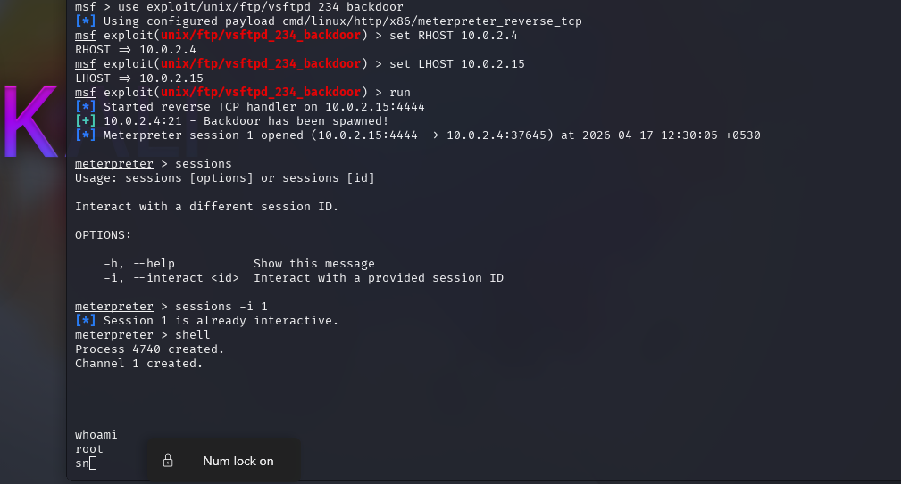
Figure 2: Successful Meterpreter Session Establishment via Metasploit

Privilege Escalation Demo
Post-exploitation activities included enumeration and privilege validation. Attempts were made to access sensitive system files and verify elevated privileges on the target system.

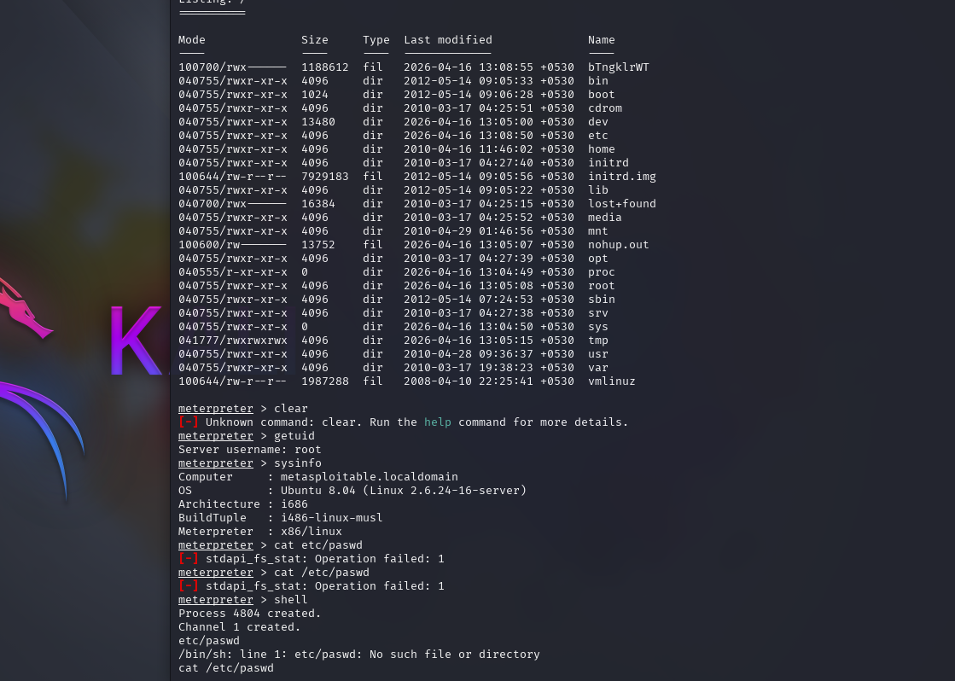Figure 3: Post-Exploitation Root Privilege Verification and System Enumeration

5. Malware Analysis
An EICAR test file was uploaded to VirusTotal to evaluate antivirus detection capabilities. Multiple security vendors successfully identified the file as a harmless antivirus test signature.
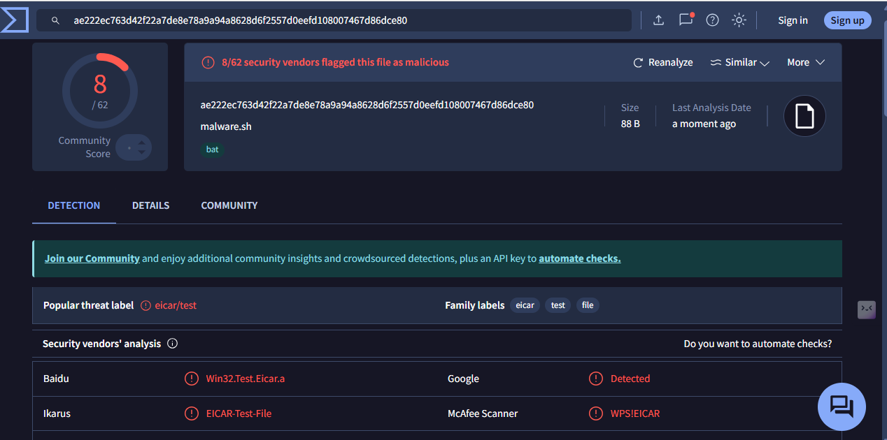
Figure 4: VirusTotal Multi-Engine Malware Detection Results for EICAR Signature

Sandbox Analysis Summary
The sandbox analysis identified the EICAR test file as a non-malicious antivirus test signature. The file demonstrated simulated malware behavior patterns without performing destructive actions. The analysis confirmed successful detection by multiple security engines.

6. Password Security
KeePassXC was used to create a secure password vault and generate strong passwords. Hydra was used to test weak password security against an FTP service.
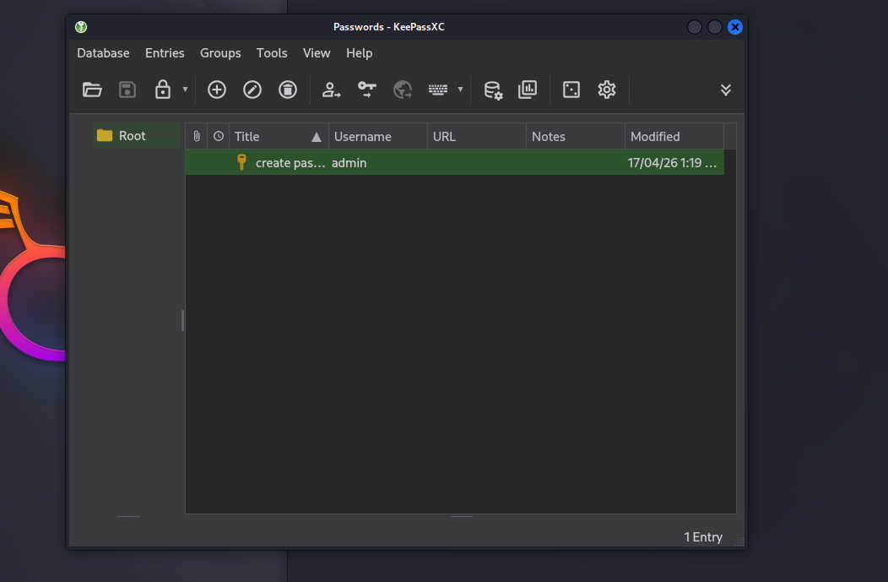
Figure 5: Secure Credential Management and Password Vault Configuration via KeePassXC

Weak Password Test Result
Hydra successfully identified the weak password 'password123' for the FTP service, demonstrating the risk associated with weak authentication policies.
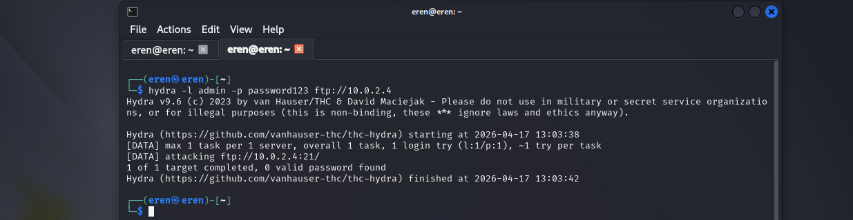
Figure 6: Automated Brute-Force Authentication Testing via Hydra

7. MITRE ATT&CK Mapping
The Metasploit exploit activity maps to MITRE ATT&CK Technique T1059 (Command and Scripting Interpreter). The engagement demonstrated remote shell execution, post-exploitation enumeration, and interactive command execution activities commonly observed during real-world intrusions.

8. Recommendations
- Regularly patch vulnerable services and applications.
- Implement strong password policies and multi-factor authentication.
- Deploy SIEM solutions such as Wazuh for centralized monitoring.
- Restrict unnecessary public-facing services.
- Monitor outbound traffic for suspicious activity.
- Conduct regular penetration testing and security assessments.

9. Conclusion
This practical assessment successfully demonstrated multiple offensive security techniques including reconnaissance, exploitation, post-exploitation, malware analysis, and password security testing. The engagement highlighted several security weaknesses and emphasized the importance of continuous monitoring, vulnerability management, strong authentication practices, and proactive incident response procedures.

